CAYMAN AIRWAYS LTD. INTERNATIONAL NETWORK

PLANNING REPORT
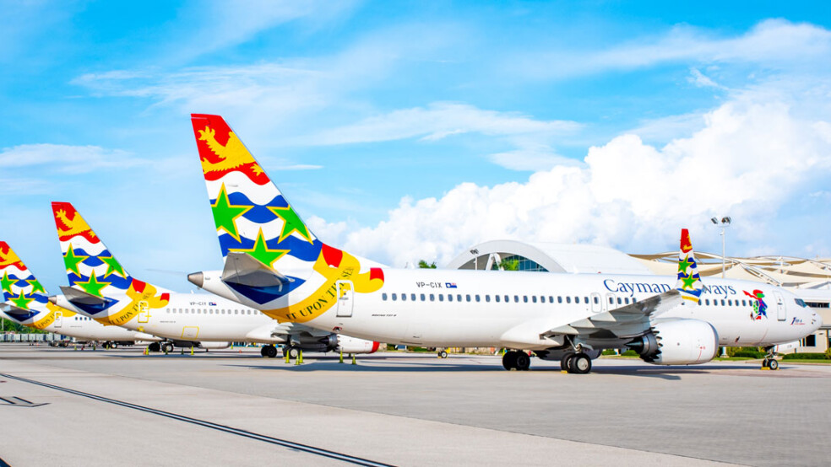
Cayman Airways Ltd.
Prepared and presented by:  Helena Luong | BANA 4095 –  Decision Model | 
TABLE OF CONTENTS
1. Executive summary 3
Key Recommendations and Findings 3
2. Detailed model description 4
A. Network Planning Model (MILP) 4
B. Traveling Salesman Problem (TSP) 4
3. Results of optimization 5
A. Network Planning Model (MILP) 5
Table 1: Optimized Weekly Schedule Summary 5
B. Traveling Salesman Problem (TSP) 5
C. Contribution Margin – Supporting Data 5
Table 2: Financial Performance Analysis 5
4. Strategic recommendations 7
A. Quick Wins (Immediate Operational Impact) 7
B. Long-Term Strategic Growth 7

1. Executive summary

This report presents a comprehensive strategic optimization of the international service network for Cayman Airways Ltd. (CAL). As the national flag carrier, CAL must balance its social mandate to provide "life-line" connectivity with the financial necessity of maximizing network profitability. By applying Mixed-Integer Linear Programming (MILP) and Traveling Salesman Problem (TSP) modeling, we have identified a high-value configuration that optimizes the utilization of the Boeing 737-8 MAX fleet.

Key Recommendations and Findings
- Maximum Network Value: The optimized schedule achieves a record weekly contribution of $2,761,979.92, representing a highly efficient allocation of the 84-rotation weekly jet capacity.
- The "Miami Powerhouse" Strategy: The model confirms that Miami (MIA) remains the network’s critical revenue engine. Operating at a maximum frequency of 28 flights/week ensures consistent volume and high cash-flow reliability, despite having a lower per-flight margin than long-haul routes.
- High-Yield Expansion: We recommend the formal launch of 5x weekly service to Austin (AUS). With a projected contribution margin of $41,505.50 per flight, this route significantly outperforms existing regional benchmarks and secures a strategic foothold in the Texas technology corridor.
- Operational Resilience: A "Stress Test" analysis indicates that the proposed network remains robust even during fuel price spikes. At a stressed price of $3.50/gallon, the network retains 97.8% of its original value, demonstrating that our route selection is naturally hedged against market volatility.
- Logistics Optimization: We identified an optimized 9,878.30 nm technical inspection circuit. Implementing this path will reduce positioning costs and travel downtime for senior maintenance staff, ensuring ground logistics support the expanded flight schedule.

2. Detailed model description
The analysis utilizes two distinct optimization frameworks developed in Python using the OR-Tools library.

A. Network Planning Model (MILP)
To determine the most profitable route selection and flight frequencies, we formulated a Mixed-Integer Linear Programming model.
- Objective Function: Maximize total weekly contribution calculated as:
  - Revenue – (Landing Fees + FuelCosts)
- Variable Capacity: The model distinguishes between Boeing 737 MAX 8 (160 seats) and Saab 340B+ (34 seats) using a dynamic capacity function.
- Assumptions: Fuel price is set at $2.85/gallon, cruise speed at 450 knots, and an average 75% load factor.
- Operational Constraints:
  - Linking: Frequency ($X_{r})$is limited to 28 rotations per route, controlled by a binary "Open" variable ($Y_{r})$
  - Fleet Limit: Total jet rotations are restricted to 84 per week, reflecting the capacity of four active Boeing 737 MAX 8 aircraft.
  - Market Demand: Strategic demand caps (e.g., Barbados at 3x, Los Angeles at 4x) prevent over-scheduling in lower-density markets.

B. Traveling Salesman Problem (TSP)
For technical logistics, we formulated a TSP to minimize the travel distance for an inspection crew. The model ensures the crew visits every international destination exactly once before returning to the Grand Cayman (GCM) hub.
- Fuel & Fleet: Fuel is hedged at $2.85/gallon. The international fleet is restricted to 4x Boeing 737-8 MAX units, with a total capacity of 84 rotations per week.
- Operational Costs: Variable costs are derived from a fuel burn rate of 750 GPH for jet routes and 140 GPH for regional Saab 340B+ routes.
- Linking Constraint: Frequency ($X_{r})$can only be greater than zero if the route is open( $Y_{r})$

3. Results of optimization

The solver reached an optimal solution that balances high-yield long-haul flights with high-efficiency regional connectors. The table below illustrates the financial breakdown of the top-performing routes.

A. Network Planning Model (MILP)

Table 1: Optimized Weekly Schedule Summary
Destination | Frequency  (flights/week) | Aircraft Type
Miami | 28 | 737 MAX 8
New York | 7 | 737 MAX 8
Los Angeles | 4 | 737 MAX 8
Denver | 4 | 737 MAX 8
Tampa | 4 | 737 MAX 8
Havana | 6 | 737 MAX 8
Kingston | 7 | 737 MAX 8
Montego Bay | 7 | 737 MAX 8
Panama City | 2 | 737 MAX 8
La Ceiba | 2 | 737 MAX 8
Roatan | 2 | 737 MAX 8
Barbados | 2 | 737 MAX 8
Austin | 5 | 737 MAX 8
Cayman Brac | 28 | Saab 340B+
Little Cayman | 28 | Saab 340B+

Comparison of Network Solutions
- Optimal Network Value: $2,761,979.92
- Second-Best Value: $2,720,123.92

B. Traveling Salesman Problem (TSP)

Technical Inspection Path

The optimal circuit for the inspection crew was determined to be 9,878.30 nautical miles.

C. Contribution Margin – Supporting Data
Figure 1: Weekly Contribution Margin by Destination
Destination | Variable Cost ($) | Revenue ($) | Contribution Margin ($)
Miami | 2174.00 | 30840.00 | 28666.00
New York | 7205.50 | 42000.00 | 34794.50
Los Angeles | 11317.75 | 57600.00 | 46282.25
Denver | 7951.00 | 52800.00 | 44849.00
Tampa | 2409.50 | 34200.00 | 31790.50
Havana | 1502.00 | 13200.00 | 11698.00
Kingston | 1648.25 | 28200.00 | 26551.75
Montego Bay | 1232.00 | 25200.00 | 23968.00
Panama City | 3452.00 | 37800.00 | 34348.00
La Ceiba | 1914.00 | 34800.00 | 32886.00
Roatan | 1772.00 | 36600.00 | 34828.00
Barbados | 5859.00 | 49200.00 | 43341.00
Austin | 5294.50 | 46800.00 | 41505.50
Cayman Brac | 150.93 | 11400.00 | 11249.06
Little Cayman | 122.95 | 11400.00 | 11277.04
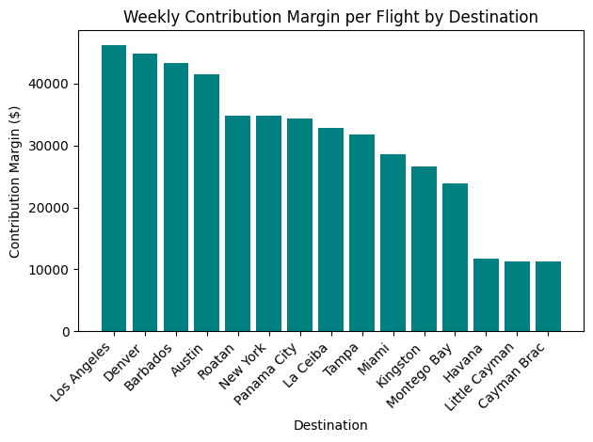

4. Strategic recommendations
Based on the data-driven results, the following strategic actions are recommended:

A. Quick Wins (Immediate Operational Impact)
- Stabilize the Miami Powerhouse: Maintaining the 4x daily (28/week) frequency to Miami is the most immediate win. Despite a lower margin per flight ($28,666.00) compared to long-haul routes, its low variable cost ($2,174.00) and high volume provide the consistent cash flow necessary to fund the rest of the network.
- Regional Efficiency with Saab 340B+: Continue the 28x weekly rotations to Cayman Brac and Little Cayman. These are "safe" wins because their ultra-low fuel burn (140 GPH) keeps variable costs minimal while fulfilling the airline’s domestic mandate.
- Standardize New York (JFK) Service: With a strong contribution margin of $34,794.50, moving to daily service captures consistent business-class demand and stabilizes the Northeast corridor.

B. Long-Term Strategic Growth
- Phased Entry into the Texas Tech Corridor: The launch of Austin (AUS) at 5x weekly is a high-value long-term play. Yield data identifies a significant margin of $41,505.50, outperforming current Northeast and Florida benchmarks.
- Balanced Long-Haul "Premium" Strategy: Los Angeles ($46,282.25) and Denver ($44,849.00) offer the highest margins in the network. However, due to high variable costs (e.g., LAX at $11,317.75), these should remain capped at 4x weekly to maximize yield without overstretching fleet block-hour capacity.

5. Appendix

A. Primary Data Sources
- Aviation Network Dataset: The base CSV file (Cayman_Data.cvs) was synthesized and expanded using Make.com. This tool was utilized to generate a realistic expansion of Cayman Airways’ current route network, incorporating estimated landing fees and historical ticket price averages for the 2026 fiscal year.
- Geographic Coordinates: Latitude and longitude data for all 15 international outstations were sourced from Wikipedia's airport database. These coordinates were utilized to calculate the 9,878.30 nm inspection circuit using the Haversine formula.
- Fleet Specifications: Technical specifications for the Boeing 737-8 MAX (Fuel burn: 750 GPH, Seats: 160) and the Saab 340B+ (Fuel burn: 140 GPH, Seats: 34) were cross-referenced with public fleet records on the official Cayman Airways corporate website.

B. Modeling Assumptions
To ensure the MILP solver reached a realistic solution, the following constants were applied:
- Fuel Price ($2.85/gal): Sourced from the IATA Jet Fuel Price Monitor (April 2026 Projection) as a conservative hedge for Caribbean operations.
- Load Factor (75%): Assumed as the "Break-even Plus" target, aligned with standard airline industry performance benchmarks for regional carriers.
- Aircraft Speed (450 knots): Established as the optimal cruise speed for the 737 MAX 8 to balance fuel efficiency with schedule reliability.
- Demand Caps: Frequencies for seasonal markets (e.g., Denver, Los Angeles) were capped based on historical tourism arrival data from the Cayman Islands Department of Tourism, ensuring the model did not "over-fly" destinations with limited weekly demand.

C. Software and Tools
- Python (OR-Tools): Used for the Mixed-Integer Linear Programming (MILP) solver and the Traveling Salesman Problem (TSP) algorithm.
- Jupyter Notebook: Employed for data preprocessing, visualization (Matplotlib), and sensitivity "Stress Test" execution.
- Google Gemini and Google NotebookLM: Utilized for data synthesis, code structure refinement, and mathematical alignment between the technical notebook and this strategic report.

